

UNITECH SERVICES GROUP LTD
Sustainability Action Plan: 282-611
Issue 2 – Oct 23
UNCONTROLLED COPY WHEN PRINTED

UNITECH SERVICES GROUP LTD DOCUMENT APPROVAL

Originator | Endorsed By | Approved By
 | 
Name P Chesters MBE  Title, Business Unit Manager | Name P Bibbings  Title, Plant Manager | Name P Chesters MBE  Title, Business Unit Manager
Date: 14/03/23 | Date: 14/03/23 | Date: 19/03/23

DOCUMENT ISSUE RECORD

Issue | Description | Date | Orig
Draft one | For Plant Comment | 14/03/23 | PC
1 | Operational Copy | 20/03/23 | PC
2 | Updated | 16/10/23 | PC

Table of contents

1 Sustainability Statement 4
2 Corporate Environmental Policy 4
3 Sustainability plan 4 Pillars 4
4 Sustainability Goals short term (By Aug 24) 5
5 Sustainability Goals Mid/Long Term (Dec 2030) 5
6 Sustainability Plan Tasking Short term (Aug 24) 6
7 Sustainability Plan Summary 7
8 Task Progression 7
9 Task One IIP Silver to Gold. 9
10 Task Two Staff training, ILM and Welfare. 10
11 Task Three Reduction of working week. 11
12 Task Four Support to local Services. 12
13 Task Five Develop business with local companies. 13
14 Task Six Development of New services. 14
15 Task Seven Cleaning of existing Solar Panels. 15
16 Task Eight Maximising the milk runs. 16
17 Task Nine Reduction of waste (cardboard and others). 17
18 Task Ten Wild flowering unused areas. 18
19 Task Eleven Installation of Water Butts. 19
20 Task Twelve Minimising PPE/RPE on sites. 20
21 Task Thirteen Power saving options. 22
22 Task Fourteen Light replacement Prog. 23
23 Task Fifteen Security Light PIR System. 25
24 Task Sixteen PIR Security Cameras 25

Sustainability Statement

UniTech is a world leader in radiological laundering and protective Lease and direct sales and Respirator/Clothing programs. We provide the dependability and high standards our customers demand wherever they are in the UK.

UniTech UK is committed to a robust Sustainability plan supporting our employees, customers, and the planet utilizing our ISO standards and Sustainability plan to ensure as near to net zero as is possible is achieved by 2040.

Corporate Environmental Policy

Sustainability plan 4 Pillars

UniTech UK will is adopting the 4 Pillar approach with time plan encompassing:

- Human
- Social
- Economic
- Environmental

Sustainability Goals short term (By Aug 24)

- Human:
  - Qualifying from Silver to Gold in Investors in People (IIP).
  - Staff ongoing training in skills areas and Promotion.
  - Specialist staff training on welfare areas of support.
  - Better working procedures and work balance for staff. (Possibly go to 4-day week or 9-day fortnight as examples).
- Social:
  - Supporting local services (Leisure and charities).
  - Employ where possible from the local community.
  - Where possible utilise local suppliers.
- Economic:
  - Staff cross trained.
  - Developing services to support local businesses.
  - New services to existing and new customer base (Transport, storage, new services, and products).
  - Work with local companies to develop both our and their businesses.
  - Cleaning regime for existing solar panels.
- Environmental:
  - Optimising routes on transport milk runs to and from customers.
  - Reduction in waste (cardboard, paper and Misc).
  - Wild flowering all underutilised grassed areas.
  - Installation of water butts to capture rainwater (used for vehicle and area washdown).
  - Minimising options of RPE/PPE at customer sites
  - Power saving devices for lights and computer equipment.

Sustainability Goals Mid/Long Term (Dec 2030)

- Human:
  - Qualifying from Gold to Platinum in Investors in People (IIP).
  - Reducing the working week for staff (Mid Term).
- Social:
  - Proper internal policy to use local/SMEs/VSCEs for smaller contracts or where appropriate.
  - Integrated social value policy and workstream.
  - Staff volunteering program/policy? Could align this to key themes or a few key charities in the local area.
- Economic:
  - Growth of workforce Long Term.
  - Developing services to support local businesses. Mid- Long Term.
  - Savings by reducing the working week (Mid Term).
- Environmental:
  - Replace existing fleet of lorries to more modern versions (Mid 2024)
  - Install more Solar Panels (Long Term).
  - Upgrade internal lighting (Mid Term).
  - Update existing machinery (Mid-Long Term).
  - Reducing the working week for staff so saving on all utilities and fuel (Mid Term).
  - Look at changing Utilities options, Wind, or new technologies (Long Term).
  - Vehicle electric charging Points for lorries and other vehicles (Long Term).

Sustainability Plan Tasking Short term (Aug 24)

Each person/Team to prepare a plan of how to achieve with relevant costs by Monday 01 May so that detailed plan can be created to action tasks below.

Task No | Project | Assigned to | completion | Notes
1 | IIP Silver to Gold | SR/PC | Aug 24 | Involvement of staff to ensure all are supporting.
2 | Staff training ILM and welfare | SR/PB/PC | Aug 24 | Mgt training and welfare cses to meet staff needs
3 | Reduce of working week from 5 days to 4 days or 9-day fortnight | PB/NM | Aug 24 | Ensure production is not affected and staff welfare
4 | Support to local services | PC/PB/NM | Aug 24 | Support to charities and local amenities
5 | Develop business with local companies | PC/PB/NM | Aug 24 | Use of local companies for services and partnerships
6 | Development of new services | PC/AM | Aug 24 | Transport, storage and other
7 | Work order for cleaning existing solar panels | NM/PB | Aug 24 | Regime to keep existing panels operating at the optimum
8 | Maximising milk runs to customer base | PB/DE/NM | Aug 24 | Supported by PC/AM
9 | Reduction of waste including Cardboard and plastic | PB/NM/AR | Aug 24 | Supported by PC/AM talking to customer base
10 | Wild flowering unused grassed areas | PC/DE | Aug 24 | Support from plant staff where needed
11 | Installation of water butts to capture rainwater | DE | Aug 24 | To be used for vehicle and area cleaning
12 | Minimising PPE/RPE in use on sites | PC/AM | Aug 24 | Already operational is RPE now need to work on PPE
13 | Power saving options for lights and computers | DE/PB/NM | Aug 24 | Savings on existing infrastructure
14 | Light replacement Prog and equipment Maint | DE/PB/NM/PC | Aug 24 | For future budgeting so we can show a drive towards reduction in environmental
15 | Rewiring of outside security lights to activate on PIR so saving on electric use | DE/PB/NM | Aug 24 | Pricing being sought to carry out this work
16 | PIR activated cameras for all key access points | PB/DE/NM | Aug 24 | For staff protection and control of site when not manned movement activated Camera’s.

Sustainability Plan Summary

UniTech plan is to have a detailed action plan for each of the tasks in the short-term projects by 31 May 23 for an achievement by close of company year-end in August 2024. Long-term projects will be detailed by Aug 2024 for budgeting or planning as is required. We are committed to achieving all the above and possibly more in the Business Year Aug 23 - Aug 24 and a continual plan to achieve even greater targets in the coming years to meet as near to net zero by 2040.

Task Progression
Task | Task Lead | Project costs vs Savings | Status of Task | Planned Completion date | Notes
1 | SR | Cost = £6,249.00 for IIP Awards and renewal of IIP Certification. | Ongoing | Aug 24 | 23 Nov 23 visit by awarding body to interview ILM students and promoted staff as part of moving to GOLD
2 | SR | Cost = £200.00 | Ongoing | Aug 24 | Training will be completed by Dec 23 and will then change to BLUE
3 | PB | Cost = N/A savings of 13% a year for utilities and staff for transport and daycare of 20% a year | Trial starts week of 05 June 23 | Aug 24 | 4 Day week instigated and going well but will be re-evaluated every 6 months.
4 | PC | Cost = UniTech will be donating £1,000 this year to 2 local entities | Donations made to:  Llanhilleth RFC  St David's Hospice Care | Aug 24 | Donations given and to a new MacMillan cancer charity. Will also donate to a Scottish charity.
5 | PC | N/A | Set up co-operations with 2 local companies | Aug 24 | Developing business with REMAR Safety, Rhino Doors and Colmony.
6 | PC | Cost = £17,000.00 Savings = N/A | New storage facility | Aug 24 | Facility now on site and will be built by Dec 23
7 | NM | Cost = £200 Savings = extra 20% solar capture | By Dec 23 | Aug 24 | Planned to be cleaned in Dec 23 when we have the relevant plant on site to access roof. Long term plan to add more panels
8 | PB | N/A | Ongoing from May 23 | Aug 24 | Sites agreed and in most cases are now fortnightly with remainder by Dec 23
9 | NM | N/A | Ongoing | Aug 24 | We are now at 85% recycling and NM will continue to monitor and report back every 6 months.
10 | DE | Cost £392.00 savings Nil however positive for environment and staff well being | Due to time of year this will now be carried out early in the new year 2024 | Aug 24 | We have the seeds but due to weather we have been told to hold off planting till early next year however bird nests will go up in Nov 23
11 | DE | Cost £432.36 savings of 28,000ltrs of water a year | Implementation 05 June 23 | Aug 24 | Completed in Sept 23 and being used for washing lorries.
12 | PC | N/A | Ongoing | Aug 24 | Was delayed but been informed by Magnox that this will start to move forward in Nov 23
13 | NM | Cost = £133.92 Savings £900 approx. a year | Implementation 05 June 23 | Aug 24 | Completed Oct 23 and will look for other savings in the new year.
14 | DE | Cost = £6,593.62 Savings £4k a year minimum | Completed Sept 23 | Aug 24 | Completed Sept 23.
15 | DE | Costs being looked at in Nov 23 | Implementation by Dec 23 | Dec 23 | Savings to be confirmed by having lights come on when required PIR.
16 | PB | Costs being looked at by mid Nov 23 | Implementation by Jan 24 | Jan 24 | PIR Security cameras for key access points

Code:
Green = Live/Ongoing
Blue = Completed
Red = Delayed/on hold

Task One IIP Silver to Gold.

Lead: SR
Team: PC

Description: To take UniTech from Silver to Gold in the current business year and then onto Platinum within 3 years.

Benefits of IIP are:

- Improve the quality of leadership skills.
- Improve management policies.
- Improve training practices.
- Improve the ability of staff to do their jobs.
- Improve staff commitment to the organisation.
- Improve productivity.
- Reduce staff turnover.
- Reduce the need to take disciplinary action staff.
- Reduce absenteeism among staff.
- Lower recruitment costs.
- Improve communication (better teamwork).

Short Term Goal we have just been invited to apply for the Investors in People Awards 2023 under the following categories.

- Individual Awards
- Organisational Awards
- Employer of the Year Awards

Staff training in the short term include:

- ILM course under way for x2 members
- HP Technician training x1
- Subsidized driving lessons for members of staff for long-term driving roles within organisation.
- CIPD Level 7 Strategic People Management x1
- Ongoing Fire and first aid training.

Create a social value policy and workstream framework (Attached is the draft Social Value policy and the Wellbeing policy is being produced currently).

Task Two Staff training, ILM and Welfare.

Lead: SR
Team: PC, PB & NM

Description: UniTech has a detailed plan and succession plan for the business and staff.

Currently working on a well-being strategy to concentrate on the following areas:

- Carry out a workplace wellbeing needs assessment.
- Create gap analysis to help identify key priorities as specific employee groups needing support.
- Hybrid working – piloting 4 day working week.
- Create a Stress Assessment to prevent short/long term absences.
  - Short-term absence costs the business £395.96 per week per person absent.
  - Long-term absence costs the business £1,187.88 per month.
- Start a yearly health and wellbeing survey.
  - Wellbeing newsletter, poster location and walk around to build engagement.
- Partake in the McMillian Coffee Morning (September) to raise money for the Charity.
- Continue advertising the EAP programme we currently have.
- Bird feeding is being created.
- Wildflower meadow being planted.

Task Three Reduction of working week.

Lead: PB
Team: NM

Description: Reducing the working week to 4-day weeks as of 05 June 23.

- We trialed the 9-day fortnight back in 2020 and was very successful, it only stopped because of the Covid 19 pandemic.
- We have decided to trial a 4-day working week for a period of 3 months and then assess whether we continue or revert to a 5-day working week, or a 9-day fortnight.
- In November 2022 we changed the total weekly plant opening hours for a 5-day week from 46 hours to 40 hours, this reduced our operating time by 6 hours. By doing this we were able to reduce our gas and electricity usage by 13%
- We achieved this by not having staggered start time between the active washroom and the rest of production. 1 HP would open the building 20 minutes before the start of the shift.
- On a 4-day working week the plant will still be open for 40 hours but will lose 1-day of heating the plant from cold to warm. This will be a small saving weekly but still a saving.
- There will be a saving of in fuel cost of 20% for the employees as they only must travel to work 4 days a week rather than 5 days. This would also be a 20% reduction in emissions to the environment.
- Employees paying for childcare would also reduce this cost by 20% when working a 4-day week.
- The welfare of the employees would improve by having 3 days off every week rather than 2 days.

Task Four Support to local Services.

Lead: PC
Team: PB & NM

Description: Currently we keep funds to support 2 local organisations along with working with others when possible.

We donated a sum of money in support of Llanhilleth RFC in May 23 and St David's Hospice Care in June 23. Extra charities supported are MacMillan cancer charity and a Scottish Charity TBC.

We are also in talks with the Helping Caring Team (HCT) to offer written off stock for use for the homeless and Vulnerable.

Task Five Develop business with local companies.

Lead: PC
Team: PB & NM

Description: Working with local companies to support our business and customer base.

Currently in the last 3 months we have set up partnerships to support our customers with 2 local companies the first being Rhino Doors and the second REMAR safety. Both these companies provide services we cannot do for our customer base. We hope to develop more partnerships over the coming months with talks ongoing.

We also use local companies for window cleaning, grounds work, recruitment, Food, vehicle maintenance and local fabrication work.

Task Six Development of New services.

Lead: PC
Team: AM

Description: New services for our customer base that can generate savings.

By mid-June we will have our new storage facility up and running that will allow our customer base and local businesses to store equipment locally and or through use of our milk run lorries. Working with our partners Ludlum we will be offering the ability to ship equipment to and from the customer sites on our milk run lorries so saving on double runs to sites helping with both costs and carbon output. Development of metal recycling for both nuclear and non-nuclear sites by using existing milk run lorries and saving on metals going to contaminated waste routes. We are also already supporting customer sites with metal decon but also disposal where possible using the recycling route which over 98% going down that route.

Task Seven Cleaning of existing Solar Panels.

Lead: NM
Team: PB/DE

Description:

Installed November 2014
System cost £82000
Feed In Tariff (FIT) payments in that time £48658 (Feed in Tariff is money received through the government scheme)
Cost savings from not buying electricity is greater than £50000 since installation.
Money from export payments i.e., electricity unused and fed back into the grid is > £5000 i.e., about 10-15 MWh per year.
Saving is about £14000 per year (based on the average of above)
Lifetime generation 471.86 MWh
CO2 Emission Saved 120,606.74 kg.

The panels have not been cleaned since installation so we will have them cleaned and area surveyed for more panels in the mid-term. The cost for the cleaning will be £200.00

Task Eight Maximising the milk runs.

Lead: PB
Team: NM & DE

Description: Move as many customers as possible to fortnightly or monthly runs.

This would allow savings both financial and environmentally for both UniTech and the customer. Currently working with Magnox and EDF to where possible do joint fortnightly runs with savings shown below once fully implemented:

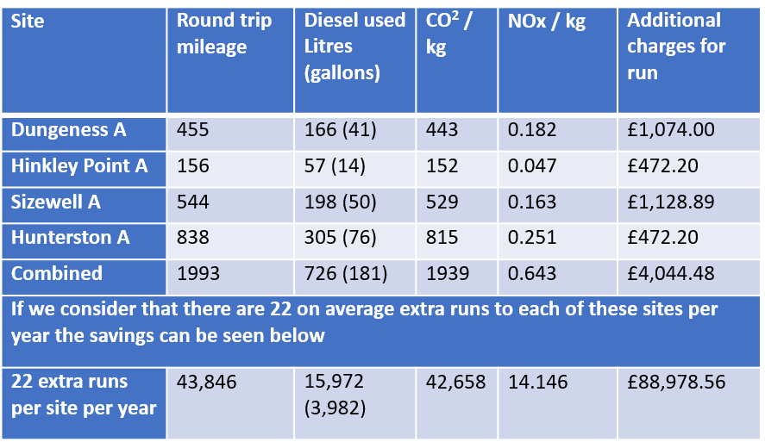

Other savings:

If all ran on fortnightly or monthly the other environmental savings are:
Wash water
Vehicles
Electric/Gas
Detergents
Hours
Less staff time used at both UniTech and sites.

We hope to have this implemented by Aug 23 with Hunterston A last the join.

Attached to this document is Proposal for Improvement of Delivery/Collection
Ref: PRPB05282001 for Magnox.

Task Nine Reduction of waste (cardboard and others).

Lead: NM
Team: PB & Team Leaders

Description: Reduce waste by recycling and working with manufacturers and customers currently we recycle 76% with a goal to increase to 85%.

Unitech produces as much waste by having to use two plastic bags, tape, and label as the actual customers non-launderable itself. (For sending back to customer site)
Possible option:
Unitech prides itself on how it is looking at means to reduce its impact on the environment whilst also making savings, but not just for itself but also in supporting its customers in their own cost & environmental saving initiatives.
  - Reduce LLW waste.
  - Save money.
  - Reduce plastic usage,
  - Save environment.

- If we were to use reusable respirator bags instead of single use plastic bags this would result in our customers’ reduction of plastic waste but not ours.
- We generally do not generate much cardboard or plastic waste; this mainly comes from packaging from our suppliers.

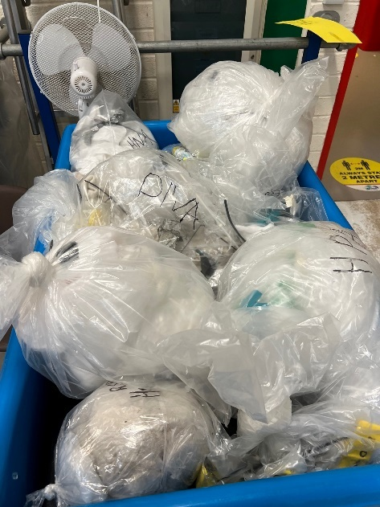
This picture shows all eight packages from various Magnox sites over the week total in weight 6.3kg

Task Ten Wild flowering unused areas.

Lead: DE
Team: PC

Description: Utilising areas of the site not used for business to develop wildflower meadows and bird feeding stations.

Having contacted local authorities and several environmental agencies the consensus is that we would need to sort this out ourselves.

There are no planning restrictions if we want to convert the grass area to a wildflower meadow.

That being said,

The approximate area to cover is 200 m2.

1 bag of wildflower seeds for from The Grass People is £96.00.

We would need 2 bags.

Total cost £192.00.

I would also propose that we hang several bird boxes and possible feeding stations for local wildlife.

These can be sourced relatively inexpensively at approx. £20 each.
I calculate that 6 would be required for our area of £120.00.
Feed for the feeders would cost approximately £80.00 a year.

Task Eleven Installation of Water Butts.

Lead: DE
Team: Drivers

Description: Install water butts to allow us to utilise rainwater for washing vehicles and possibly in the metal decon area for cleaning work.

Rainwater capture to be used for Lorry cleaning and outside yard cleaning.
Currently we use mains water for the cleaning of the trucks at the plant.
To clean 1 truck uses approx. 200ltrs of water from the mains.
The trucks are cleaned usually once a week, therefore 3x truck clean uses approx. 600 litres of water.
This equates to approx. 28000ltres of water per year (based on average use)
A water butt that holds 1000ltrs of water should be suitable for the job. (Another one could be bought if required)
Costing.

2x 1000ltr IBC = 332.38+VAT
2x Rain collector fitting for one downpipe. = £98.00+VAT.
Length of hose we already have so no cost.

The cost of water currently to wash trucks based on £1.60 per Cubic meter is £44.80 per year.

Cost of Rainwater recycling system £432.36

This would effectively take 10 years to become profitable. However, the environmental benefits in my opinion out way this relatively small cost.

Please note this is based on water usage for the truck washing only.

Task Twelve Minimising PPE/RPE on sites.

Lead: PC
Team: AM

Description: Working with the customer base on minimising holdings of PPE/RPE to make savings on holdings, costs, waste, and processing costs. We have in 2021 we started the first new service to meet the above and that is the Respirator Pool with a plan to start a Coverall Pool in the next 12 months.

Magnox Respirator Pool:

Until the Pool was introduced the sites had a mix of lease and owned respirators totalling over 8,000+ of the Phantom version and possibly another 4,000 minimum of other options. All the Phantoms are now obsolete so must be removed and replaced. Under the Pool system UniTech will hold up to 3500 respirators and move them around the fleet as required to meet project and work needs. This is a saving of over 4000 respirators that would have been held at a cost of over £1,800,000.00 and probably not needed as yearly usage we believe will result in a need of max of 3,500. This also ensures the pool respirators are used to the maximum.

Currently UniTech is looking at options for environmentally friendly route for the old respirators including shredding and then sent for incineration generating clean electricity.

EDF Respirator Pool plan:

This is in the early stages, but 2 sites are already using the leased proflow systems and we hope to bring the rest of the fleet on board following the same route as Magnox above.

Magnox C2 Coverall Pool plan:

As with the Respirators above it is believed that the sites have leased and owned over 30,000 coveralls of various designs and material. The proposal is to replace with a pool of 14-15,000 new design coveralls that will be issued to sites as needed. With the new coverall pool the design and material will be lighter and newer than the old technology coveralls allowing more to be shipped in the containers and they can be washed as a full load so saving on water, utilities, and cleansing product.

Reusable Launderable bags:

We are supporting sites with launderable bags to replace plastic with Magnox using them for respirators and EDF using for over the barrier use to minimise rad waste. It is difficult to calculate waste savings, but it is likely to be over £50,000.00 a year in rad waste minimum.

Below is an independent report showing the advantages of launderable over disposable:

UniTech Services Group commissioned PE International, a global leader in sustainability performance solutions, to conduct an independent comparison of the environmental performance of UniTech reusable protective clothing set with a disposable garment set. The study compared the cradle-to-grave impacts of two garment sets used for low level radioactive particulate contamination protection and contamination control. It measured specific areas of impact including global warming potential, acidification smog formation, ozone depletion, and other potential areas of impact.
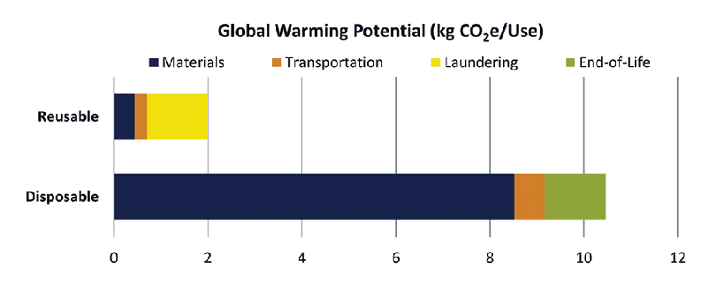

UniTech reusable garments had remarkably less impact in all categories measured, with the most significant (five-fold or more) differences being in global warming potential, smog, and primary energy demand.

Task Thirteen Power saving options.

Lead: NM
Team: PB & DE

Description: Installation of PIR to save on power usage and lights left on around site and options for computers.

Proposed PIR locations: -
Upstairs toilets X2
Upstairs Kitchenette
Downstairs toilets X2
Air compressor room
Downstairs Kitchenette
Downstairs canteen
File storage room
Power room
Downstairs storage cupboard
Upstairs storage cupboard
Warehouse

12x Light PIR switches @£11.16 each.
Total cost £133.92

By installing PIR sensors in the key areas proposed.

3300watts @ 0.18p/kwh would equal £22.57 per week.

This equates to £1173.64 per year based on lights being left on all day.

If we installed PIR sensors in these key areas, I propose we could reduce the lights on time by 80%.

This would reduce the cost to £234.73.

A potential saving of £938.91.

Installation could be carried out by DE as we are only replacing existing light switches.

Most computers typically consume between 3 to 10 watts in sleep mode. To run a computer in sleep mode for a day (24h), it will cost you 0.04 pence by the current price of 18 pence per kWh. During normal mode, the desktop computer uses 60 to 300 watts of power which is around 30 times more than in sleep mode. 10 PC on all weekends would cost 0.80 pence per weekend.
https://www.thehomehacksdiy.com/how-much-power-does-a-computer-use-in-sleep-mode/?utm_content=cmp-true

A possible option for computers is to ensure all printers and anciles are switched off and unplugged and the same for any computers that do not need to be left in sleep mode.

Task Fourteen Light replacement Prog.

Lead: DE
Team: PC/PB/NM & AM

Description: Replacement prog for all fluorescent tubes to LED on the shop floor, warehouse and all other areas including offices.

6ft Fluorescent tubes to LED on shop floor, warehouse, and some other areas.

Task: -
To find an alternate method of lighting the plant which will be more cost effective.
Facts: -
The current amount of 6ft Fluorescent tubes on plant is 337.
These are all Fluorescent 70w tubes.
337x70w=23,590watts consumption.
At our current electricity cost of 18pence p/kwh, this equates to a cost of £161.36 per week. (Based on all lights on at once all day)
Which is £8390.72p (Based on a 52-week working year)
Obviously, all the lights are not on at the same time so a more realistic assumption would be that 70% of the lights would be on at any given time.
This would give a figure of £5873.50 cost to light the shop floor and washrooms per year. (Based on 70% Usage).

Please note we are currently on a fixed tariff for our electricity of 18p p/kwh.
This runs out in September.
Based on the current available tariffs this could go up to 35p/kwh.
This would be £313.75 per week.
This would increase the expenditure to £11,420.50p (Based on 70% usage)
Cost of electricity @ 18p/kwh
£5873.50
Cost of electricity @ 35p/kwh
£11,420.50

Replacing the current fluorescent tubes to LED

Cost of 337 6ft LED Tubes from LIGHTBULBS DIRECT
https://www.lightbulbs-direct.com/cart.php
£5,547.02p

LED tubes are 28w each. Therefor 337x28w=9439w
At our current electricity cost of 18pence p/kwh, this equates to a cost of £64.56 per week. (Based on all lights on at once all day)

Cost to light the shop floor and washrooms per year is £64.56 x 52= £3357.12p

Based on 70% light usage per day the cost is £2349.98p per year.

Cost to light the shop floor and washrooms per year: -

6ft Fluorescent Tubes £5873.5
6ft LED Tubes £2349.98
This is a saving per year of £3523.52 per year.

Considering the cost of the replacement lights at £5547.02p

This would mean that we would be saving £3523.52 per year after 18 months.

2ft Fluorescent tubes in office areas to LED

Fact:
86 Fluorescent tubes @18w each.
This equates to £550.68 per year. (100% Usage)
Realistically only 70% are used at any one time.
Therefore: -
£385.48 per year to light offices and hallways.

2ft LED tubes are 9w therefore 50% saving on current fluorescent light costs. £192.80

2ft Fluorescent tubes cost £385.48 per year.
2ft LED tubes cost £192.80 per year.

Saving of £192.80 per year

The cost of LED replacement Tubes from Lightbulbs direct is £606.60.
https://www.lightbulbs-direct.com/cart.php

This would mean that after 3 years we would be saving £192.80p per year.

Summary:

Total cost to implement all above would be £6,153.62p with a saving on electric of approx. £3,000.00 per year.

Also, some other key points to note are:

- Fluorescent tubes are to be banned in the UK from September 2023 onwards. So, we must make the change anyway.
- LED tubes have double the life of fluorescent tubes.
- Fluorescent Tube disposal is £1.10 per tube so the total cost is approx. £440.00 (based on 400 tubes).
- LED tubes are made of 100% recyclable material.
- LED Tubes do not contain any harmful gases.

Task Fifteen Security Light PIR System.

Lead: DE
Team: PB/NM

Description: Change outside security lights to PIR activated to save on costs of running them.

Costing.

TBC by November 23.

Task Sixteen PIR Security Cameras

Lead: PB
Team: DE/NM

Description: For staff and site protection add PIR activated cameras linked to call out phone to allow quicker action should a crime be happening when site not manned.

Costing.

TBC by November 23.

